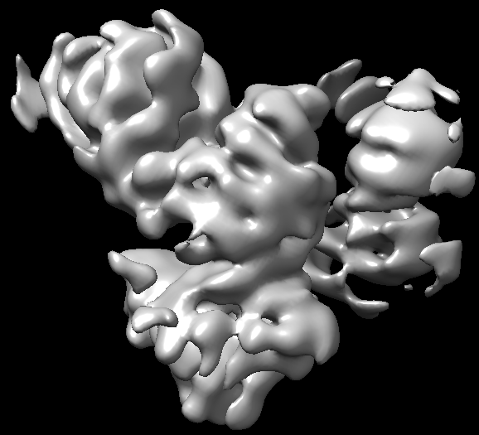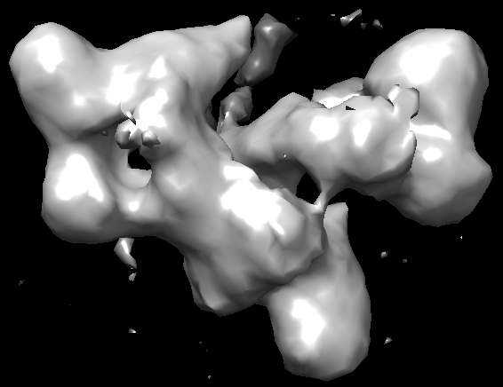

startup-volume_1_1.mrc (created by ab-initio 3D)

Volume_19_1.mrc (after auto-refinement)